Matrix manipulations, Graph Translations, and drawing networks (Week 2 Assignment)
(This is adapted from assignment created by James Moody)

Writing networks
1) Transform the network below into (a) an adjacency matrix, (b) an adjacency list and (c) an arc list.

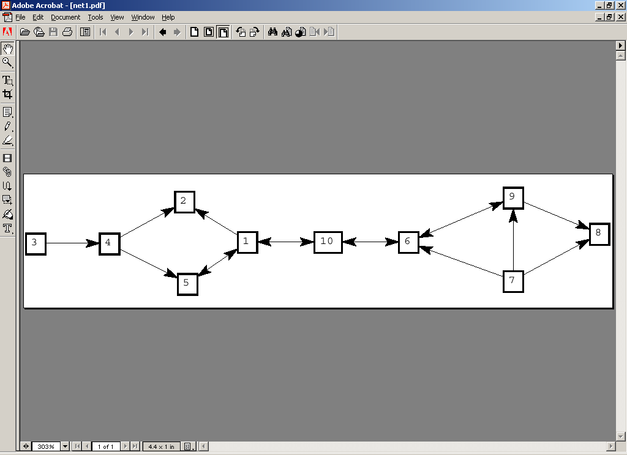

Adjacency Matrix

 | 1 | 2 | 3 | 4 | 5 | 6 | 7 | 8 | 9 | 10
1 |  | 1 |  |  | 1 |  |  |  |  | 1
2
3 |  |  |  | 1
4 |  | 1 |  |  | 1
5 | 1
6 |  |  |  |  |  |  |  |  | 1 | 1
7 |  |  |  |  |  | 1 |  | 1 | 1
8
9 |  |  |  |  |  | 1 |  | 1
10 | 1 |  |  |  |  | 1

Arc List
1 2
1 5
1 10
3 4
4 2
4 5
5 1
6 9
7 6
9 6
10 1
10 6

Adjacency List

1 2 5 10
2
3 4
4 2 5
5 1
5 9 10
7 6 8 9
8
9 6 8
10 6 1

- Transform the following networks into drawings (by hand is fine):

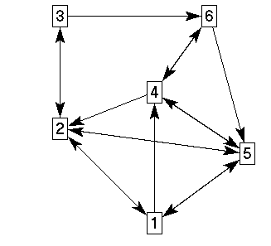
- Adjacency Matrix:
0 1 0 1 1 0
1 0 1 0 1 0
0 1 0 0 0 1
0 1 0 0 1 1
1 1 0 1 0 0
0 0 0 1 1 0

- Adjacency list:
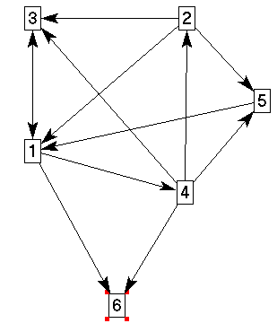
1 6 3 4
2 1 3 5
3 1 2
4 2 3 5 6
5 1
6

Using network analysis software
In each of the following, you will create some data by hand and create a random network. Then you will manipulate the data in various ways. In general, we use programs like Excel to write our data for us, since it is too cumbersome to do it by hand.

- PAJEK. PAJEK is a free network analysis and drawing program. The manual is sparse, though getting better (see their webpage. It basically details every function PAJEK does by walking through the menu). Note that PAJEK comes packaged with UCINET 6 now, though it likely won't be the most recent version (it should be in Analytic Technologies>Helper Apps).
- Create a small network by hand. Input the network in 2a (above). You can do this on-screen or by writing a small program.

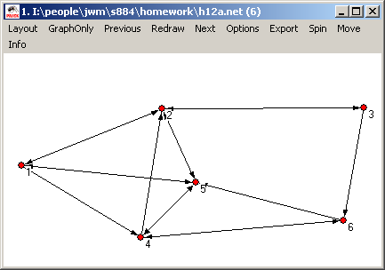

- Create and plot a random network.

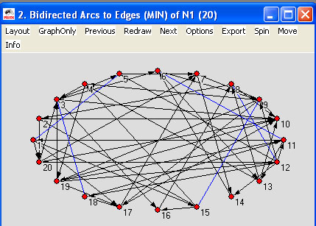

- UCINET
- Create a small network by hand. Input the network in 2a (above). To do it by hand, use the following steps:

DISPLAY
--------------------------------------------------------------------------------

Width of field: MIN
# of decimals: MIN
Rows to display: all
Columns to display: all
Row partition:
Column partition:
Input dataset: C:\Program Files\Analytic Technologies\Ucinet 6\DataFiles\Assign2Test

1 2 3 4 5 6
- - - - - -
1 0 1 0 1 1 0
2 1 0 1 0 1 0
3 0 1 0 0 0 1
4 0 1 0 0 1 1
5 1 1 0 1 0 0
6 0 0 0 1 1 0

Matrix has 6 rows, 6 columns, and 1 levels.

----------------------------------------
Running time: 00:00:01
Output generated: 20 Jan 09 18:38:07
Copyright (c) 1999-2008 Analytic Technologies

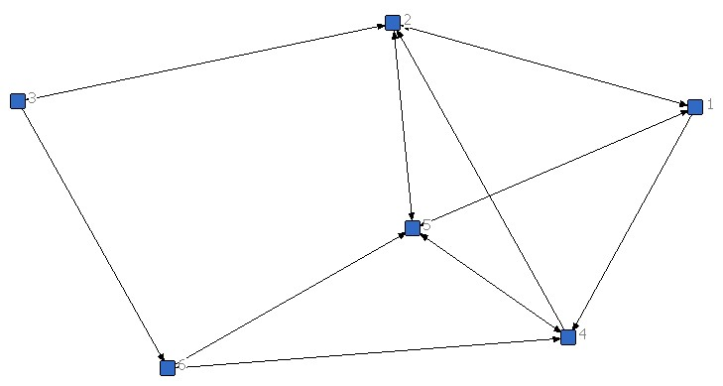

- Create and plot a random network.

DISPLAY
--------------------------------------------------------------------------------

Width of field: MIN
# of decimals: MIN
Rows to display: all
Columns to display: all
Row partition:
Column partition:
Input dataset: C:\Program Files\Analytic Technologies\Ucinet 6\DataFiles\RandomExercise

1 1 1 1 1 1 1 1 1 1 2
1 2 3 4 5 6 7 8 9 0 1 2 3 4 5 6 7 8 9 0
- - - - - - - - - - - - - - - - - - - -
1 0 0 0 0 1 0 0 0 1 0 1 0 1 1 0 0 1 0 0 0
2 1 0 0 0 0 0 0 1 0 0 0 0 1 1 1 1 0 0 1 0
3 0 1 0 0 0 1 1 0 0 0 0 0 0 0 1 1 0 1 1 0
4 0 1 0 1 0 0 0 0 1 1 1 0 0 0 1 0 1 0 0 0
5 0 0 0 0 0 0 0 1 0 0 0 1 0 1 0 0 0 0 0 0
6 1 0 1 0 0 1 0 0 0 0 0 0 0 0 1 0 0 0 0 0
7 0 0 1 0 1 0 0 0 1 1 0 1 0 0 0 0 0 1 1 1
8 0 1 0 0 1 1 0 0 0 1 0 0 0 1 0 0 0 0 0 0
9 1 0 0 0 1 0 0 0 0 0 0 0 0 0 0 0 1 0 0 1
10 0 1 0 0 1 0 0 0 1 0 1 0 0 0 0 0 0 1 0 0
11 1 1 1 0 0 0 1 0 1 1 0 1 0 0 0 0 0 0 1 0
12 0 0 0 1 0 0 0 0 1 1 0 1 0 0 0 0 0 0 1 0
13 0 1 0 0 1 1 0 0 0 0 1 0 1 0 0 0 0 0 0 0
14 0 1 0 0 0 1 0 0 0 1 0 1 0 0 0 0 0 0 0 0
15 0 0 1 1 0 0 0 0 1 0 0 0 0 1 0 0 0 0 0 0
16 0 1 0 0 0 0 0 0 0 0 1 0 1 0 0 0 0 0 0 1
17 0 0 0 0 0 0 0 1 0 0 1 0 0 1 0 1 1 0 0 0
18 0 1 0 0 0 0 0 0 1 0 1 1 1 0 0 0 0 0 0 0
19 0 0 0 0 0 1 0 0 0 0 0 0 0 0 1 0 0 0 1 1
20 1 0 1 0 0 0 0 0 1 0 1 0 0 1 0 1 0 0 0 0

Matrix has 20 rows, 20 columns, and 1 levels.

----------------------------------------
Running time: 00:00:01
Output generated: 20 Jan 09 18:58:12
Copyright (c) 1999-2008 Analytic Technologies

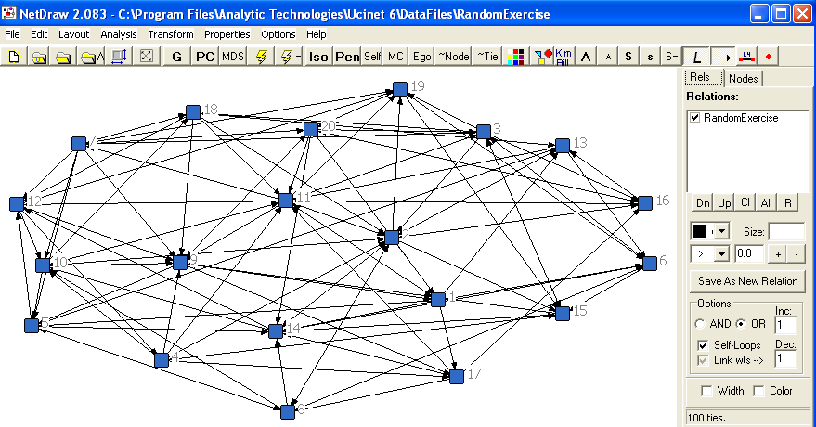

- Reachability
- Take the adjacency matrix in 2a (call it A) and compute A*A (A² ) using matrix multiplication. If you are not familiar with matrix multiplication see example in W&F p. 158.

0 1 0 1 1 0
1 0 1 0 1 0
0 1 0 0 0 1
0 1 0 0 1 1
1 1 0 1 0 0
0 0 0 1 1 0

2 | 2 | 1 | 1 | 2 | 1
1 | 3 | 0 | 2 | 1 | 1
1 | 0 | 1 | 1 | 2 | 0
2 | 1 | 1 | 2 | 2 | 0
1 | 2 | 1 | 1 | 2 | 1
1 | 2 | 0 | 1 | 1 | 1

X² =

0 | 1 | 2 | 1 | 1 | 2
1 | 0 | 1 | 2 | 1 | 2
2 | 1 | 0 | 2 | 2 | 1
2 | 1 | 2 | 0 | 1 | 1
1 | 1 | 0 | 1 | 0 | 2
2 | 2 | 3 | 1 | 1 | 0

D =

GEODESIC DISTANCE
--------------------------------------------------------------------------------

Type of data: ADJACENCY
Nearness transform: NONE
Input dataset: C:\Program Files\Analytic Technologies\Ucinet 6\DataFiles\Assign2Test
Output distance: C:\Program Files\Analytic Technologies\Ucinet 6\DataFiles\Assign2Test-Geo

For each pair of nodes, the algorithm finds the # of edges in the shortest path
between them.
Average distance = 1.500
Distance-based cohesion ("Compactness") = 0.761
(range 0 to 1; larger values indicate greater cohesiveness)
Distance-weighted fragmentation ("Breadth") = 0.239

Frequencies of Geodesic Distances

Freque Propor
------ ------
1 16.000 0.533
2 13.000 0.433
3 1.000 0.033

Geodesic Distances

1 2 3 4 5 6
- - - - - -
1 0 1 2 1 1 2
2 1 0 1 2 1 2
3 2 1 0 2 2 1
4 2 1 2 0 1 1
5 1 1 2 1 0 2
6 2 2 3 1 1 0

Distance matrix saved as dataset C:\Program Files\Analytic Technologies\Ucinet 6\DataFiles\Assign2Test-Geo

